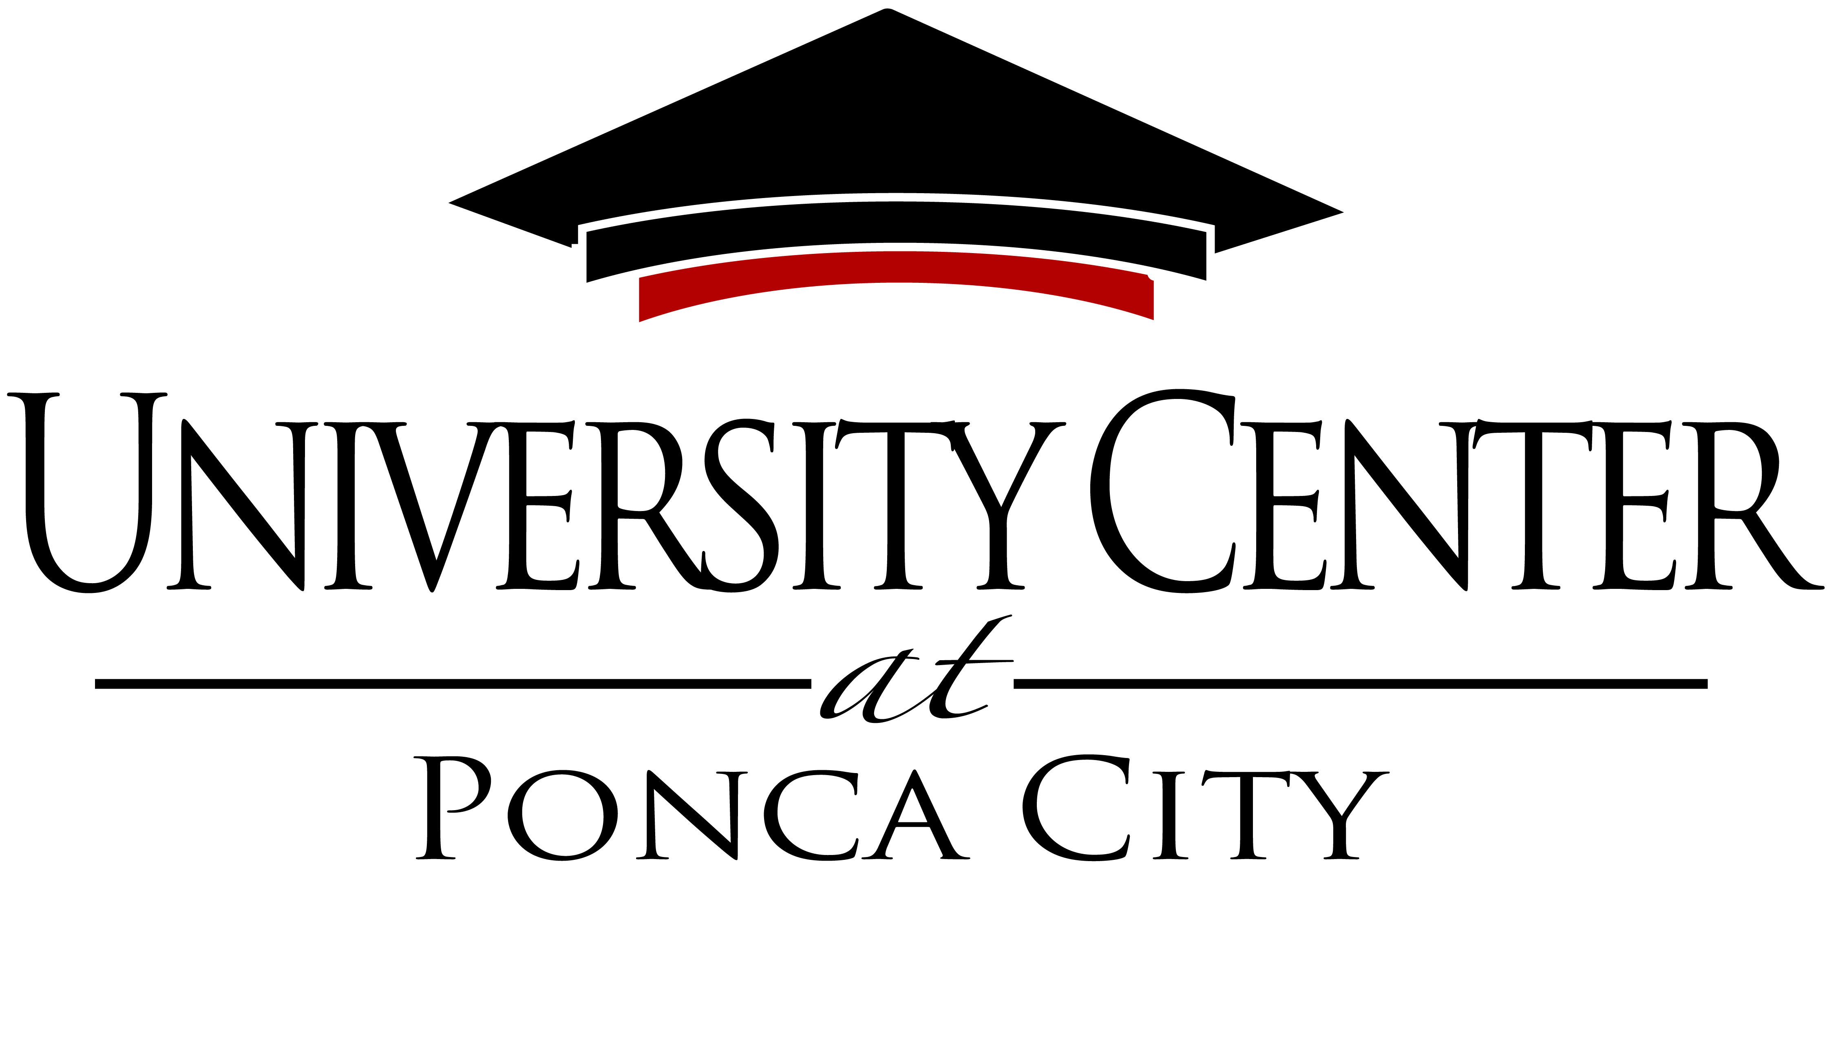

Our Vision
To be an essential higher education center that promotes a well-educated community & provides a positive economic impact.
Our Mission
The University Center provides opportunities for higher education & degrees through partnerships with accredited colleges & universities.

University Center at Ponca City
Regular Meeting for the Board of Trustees
University Center at Ponca City Conference Room
2800 N. 14th Street, Ponca City, OK 74601

Agenda
Thursday, September 7, 2023, 8:30 a.m.

- Call meeting to order, take roll call, & announcement of quorum.
- Announcements & introduction of guests.

- Presentation from NOC’s Dr. Rick Edgington about NOC Enrollment

- Discussion & action to approve or not approve the Minutes from the August 3, 2023, Regular Meeting

- Discussion & action to approve or not approve the Minutes from the August 3, 2023, Special Meeting

- Discussion & action to approve or not approve the Month-End Budget Report & details for July 2023

- Discussion & action to approve or not approve adding a policy for paid Maternity Leave to the University Center Policies & Procedures manual. Oklahoma Statutes as Section 840-2.20D of Title 74

- Discussion & action to approve or not approve adding a policy for merchandise sales to the University Center Policies & Procedures manual.

- Foundation Report- UCF Chair Diane Anderson

- Administrative Reports- CEO Robyn Armstrong

- New Business- New business is defined by 25 OS 311.A.9 as any matter not known about or which could not have been reasonably foreseen prior to the time of posting the agenda.

- Public comments.

- Comments from the UC Chair & Board Discussion.

- Announcement of next Regular Board of Trustees meeting to be held Thursday, November 2, 2023, at 8:30 a.m. in the University Center Conference Room at the University Center, 2800 N. 14th Street, Ponca City, Oklahoma.

- Motion & vote to adjourn.

NOTE: The Board of Trustees may discuss, make motions & vote upon all matters appearing on this agenda. Such votes may be to adopt, reject, table, reaffirm, rescind, or take no action on any agenda matter. This agenda was posted by 8:30 a.m. on the 5th day of September 2023, at the Main Entrance of the University Center at Ponca City, 2800 N. 14th Street, Ponca City, Oklahoma.
The University Center Core Values
Accountability – we take responsibility for our actions & honor our commitments. Collaboration – together with our partners, we seek creative approaches to learning that benefit our students. Customer Service – we are dedicated to meeting & exceeding the expectations & requirements of our internal & external customers. Innovation – we will be progressive & creative in our approaches to problem solving & goal accomplishment. Integrity – we are guided by the highest ethical & moral principles & will strive to always do the right thing. Learning – we will seek to create an environment that supports life-long learning.

