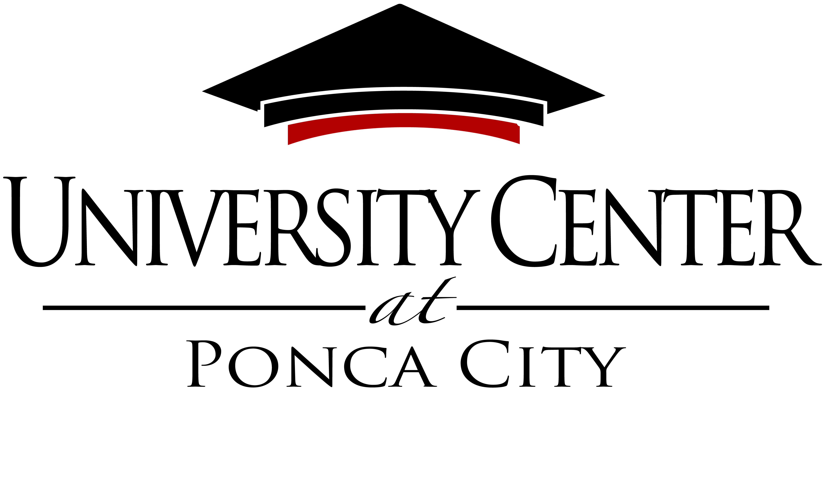

Our Vision
To be an essential higher education center that promotes a well-educated community and provides a positive economic impact.
Our Mission
The University Center provides opportunities for higher education and degrees through partnerships with accredited colleges and universities.

Agenda

August 3, 2023

SPECIAL MEETING: STRATEGIC PLANNING THURSDAY
UNIVERSITY CENTER AT PONCA CITY 08/03/2023
CONFERENCE ROOM 10:00 am
2800 N. 14TH STREET
Ponca City, OK 74601

- Call meeting to order- Board Chair Steve Scott

- Welcome board members and guests– UC CEO Robyn Armstrong

- Goals of the board discussion

- Adjourn.
NO DECISIONS WILL BE MADE AT THIS MEETING

This agenda was posted by 8:30 a.m. on the 1st day of August 2023, at the Main Entrance of the University Center at Ponca City, 2800 N. 14th Street, Ponca City, Oklahoma.
The University Center Core Values
Accountability – we take responsibility for our actions and honor our commitments. Collaboration – together with our partners, we seek creative approaches to learning that benefit our students. Customer Service – we are dedicated to meeting and exceeding the expectations and requirements of our internal and external customers. Innovation – we will be progressive and creative in our approaches to problem solving and goal accomplishment. Integrity – we are guided by the highest ethical and moral principles and will strive to always do the right thing. Learning – we will seek to create an environment that supports life-long learning.

